Official league roster - Basketball
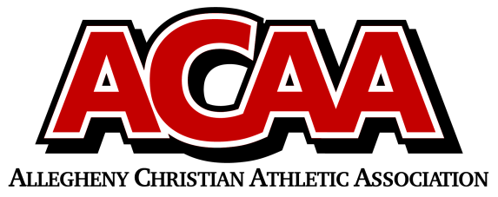

School Name:
Team Colors:
Overall Wins ___ Losses ____ Ties ___
ACAA Wins ___ Losses ____ Ties ___ OPPONENT: __________________________
Date: _________
Number | Name | Year | Position | Height | Homeschool
13 | Ethan Ginther | 12 | g | 6’ 0”
22 | Evan Peachey | 7 | g | 5’ 3”
30 | Jacob McCarty | 11 | f | 6’ 5”
31 | Raymond Kurtz | 12 | g | 5’ 10”
32 | Mark Harven | 12 | c | 6’ 6”
33 | Henry Morningstar | 11 | f | 5’ 8”
44 | Caleb Duey | 7 | f | 5’ 8”

Head Coach: steve Guisler
Asst. coach: jason mccarty
Asst. coach:

Official ACAA League Team Roster. to be submitted to the scorer’s table before each game.

